**PROJECT RESULT UPON COMPLETION.**

The application looks like this

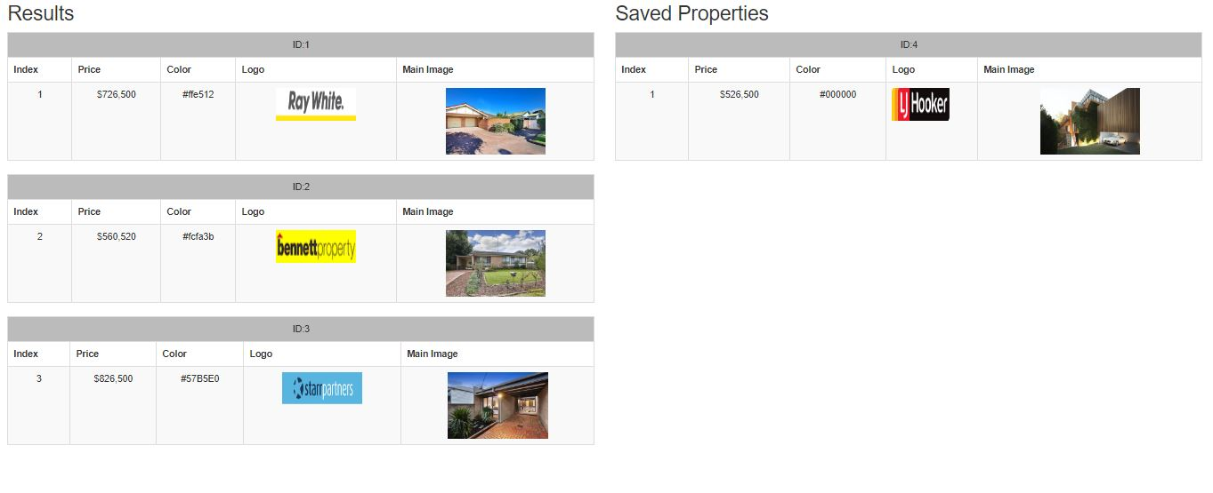

On hovering on a particular property it displays the add property or delete property button depending on what you are hovering upon

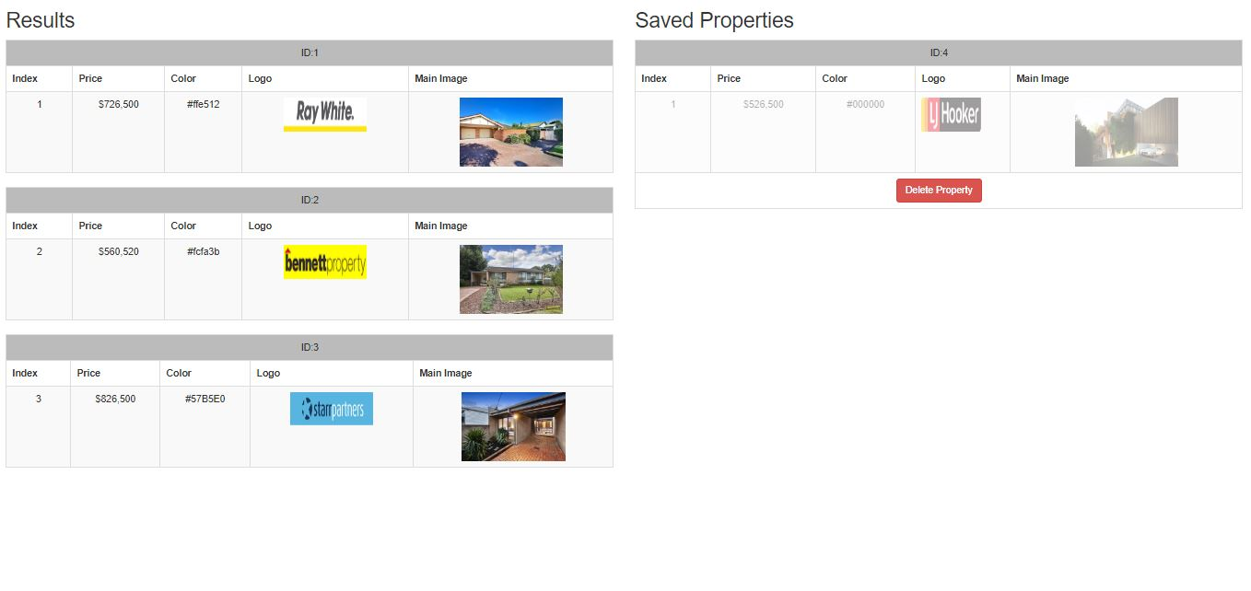

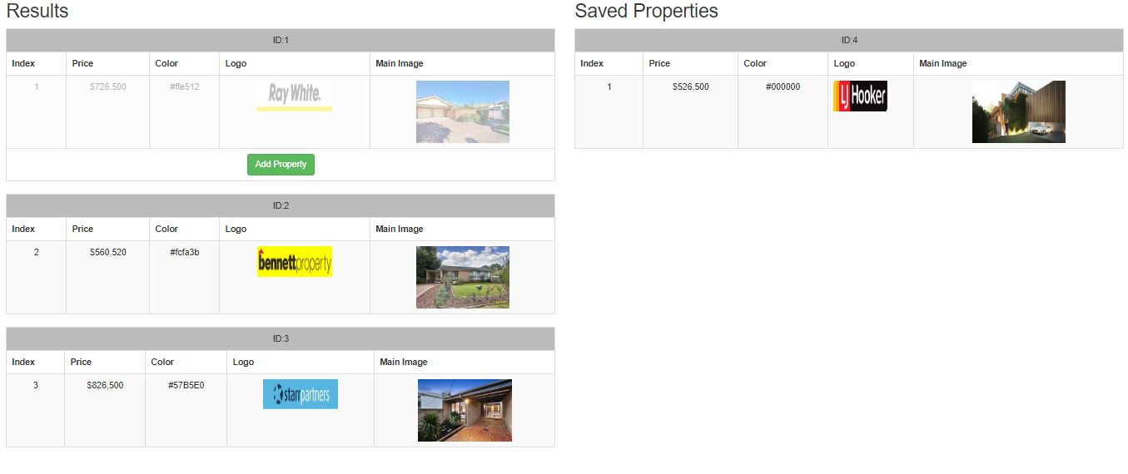

On clicking the Add Property button, property is added to Saved Properties from the Results.

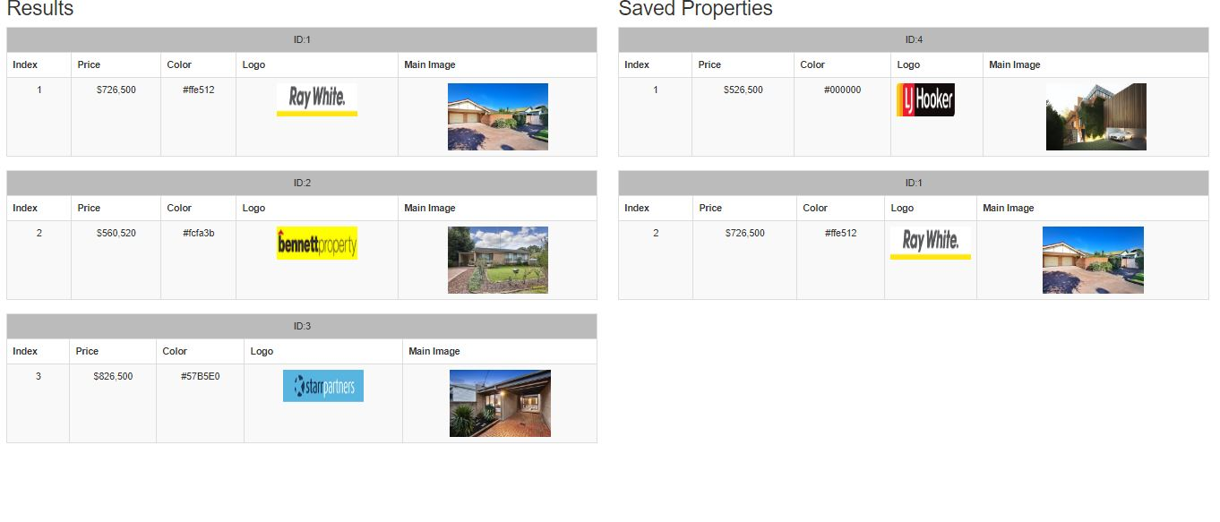

When you try to add a property that is already present in the saved properties, it throws an alert saying that **property already added. Cannot add a duplicate.**

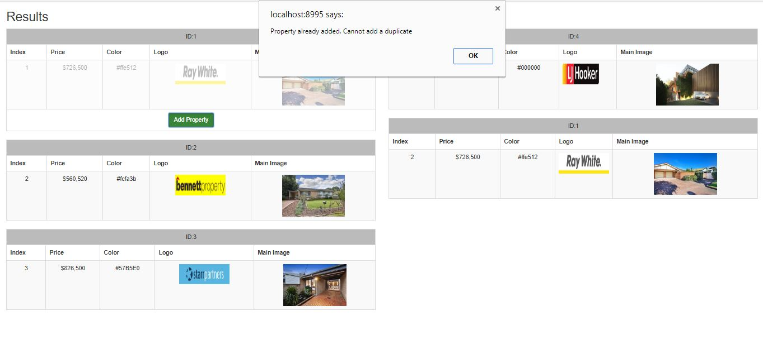

We can add all the properties to Saved Properties by clicking on Add Property button

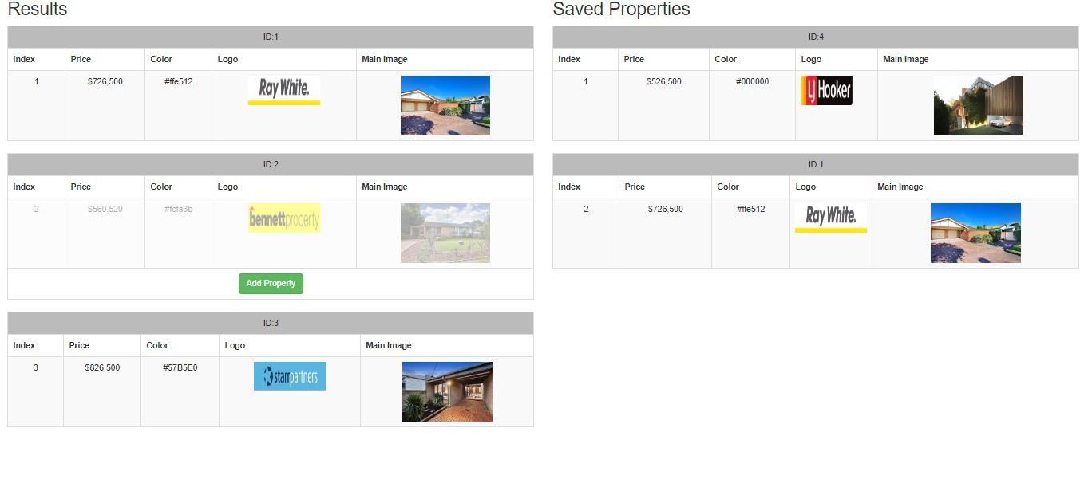

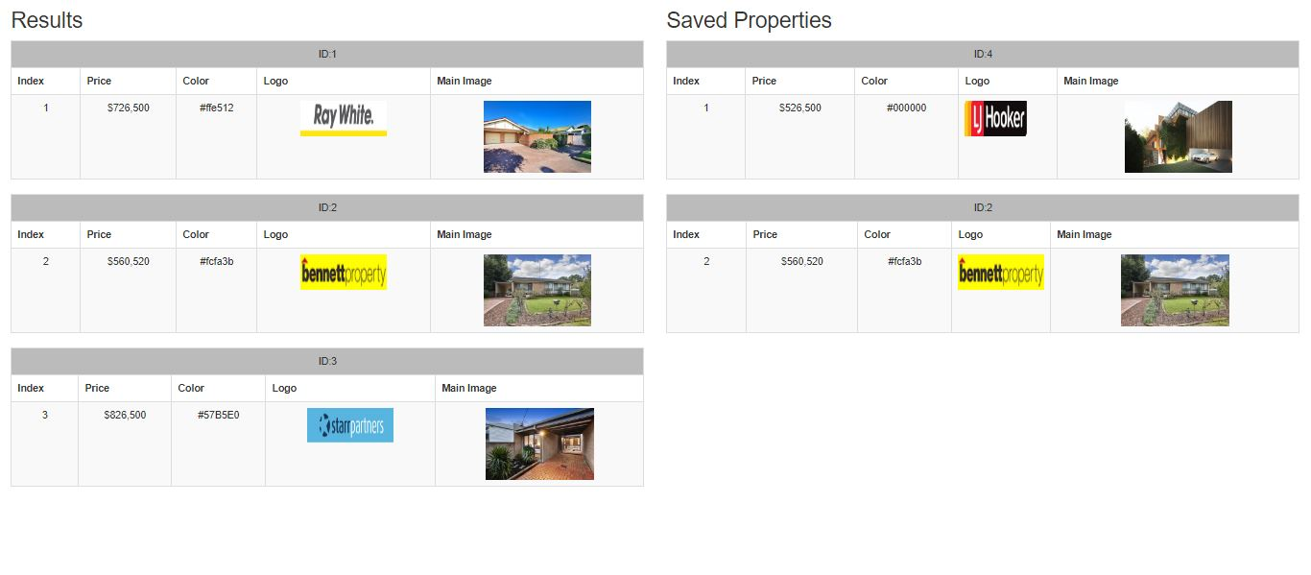

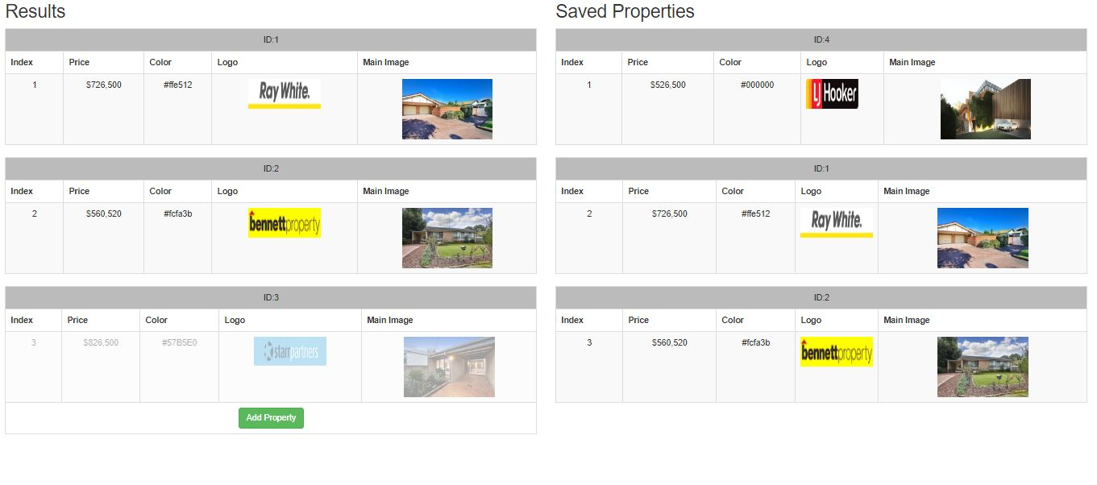

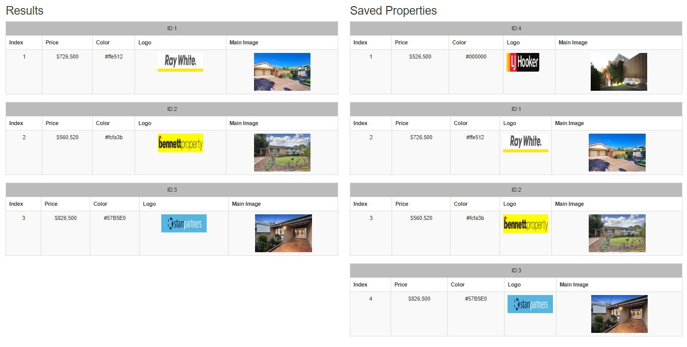

Delete a property from saved properties by clicking on Delete Property button that appears on hovering upon a property from Saved Properties.

